Construction of whole-genome perturb-seq genotype-phenotype maps and analysis of key phenotypes

I. Research Background

The mapping relationship between genotype and phenotype is a core issue in genetic research. Traditional forward genetics and reverse genetics methods have limitations: the former relies on low-dimensional phenotypic screening, while the latter struggles to achieve systematic analysis on a genome-wide scale.

Mapping information-rich genotype-phenotype landscapes with genome-scale Perturb-seq. Cell, 185(14)This work usesPerturb-seq technology combined with CRISPR Guided gene perturbation and single-cell RNA sequencing can simultaneously acquire gene perturbation information at the single-cell level and high-dimensional transcriptome phenotypes, providing a basis for constructing comprehensive genotype-phenotype mapping.pictureThe spectrum provides the possibility.

II. Data Sources

We downloaded three datasets from the website provided in the literature (https://gwps.wi.mit.edu/): K562_essential_normalized_bulk_01.h5ad

K562_gwps_normalized_bulk_01.h5ad

Rpe1_normalized_bulk_01.h5ad

thisIncludesCRISPRi screen data for two cell lines were provided. K562 included perturbation data for all genes and essential genes, while Rpe1 only contained data for essential genes. According to the methodology section of the article, the downloaded data underwent alignment, UMI-collapsed and aggregated analysis, sgRNA identification, z-normalizion, and energy distance and Anderson darling tests.

III. Paper Copying

1. Quality control and strong disturbance screening

We first selected high-quality on-target perturbations using the same method as the original literature, and then distinguished between strong and weak perturbations. The literature selection method is as follows:

High-quality knockdown: Expression levels decreased by at least 30% relative to the control group.

Strong perturbation: Anderson-Darling analysis, after Benjamini-Hochberg correction, identified at least 50 genes that differed significantly from the control group.

Weak perturbation: Anderson-Darling, after Benjamini-Hochberg correction, found fewer than 5 genes that differed significantly from the control group.

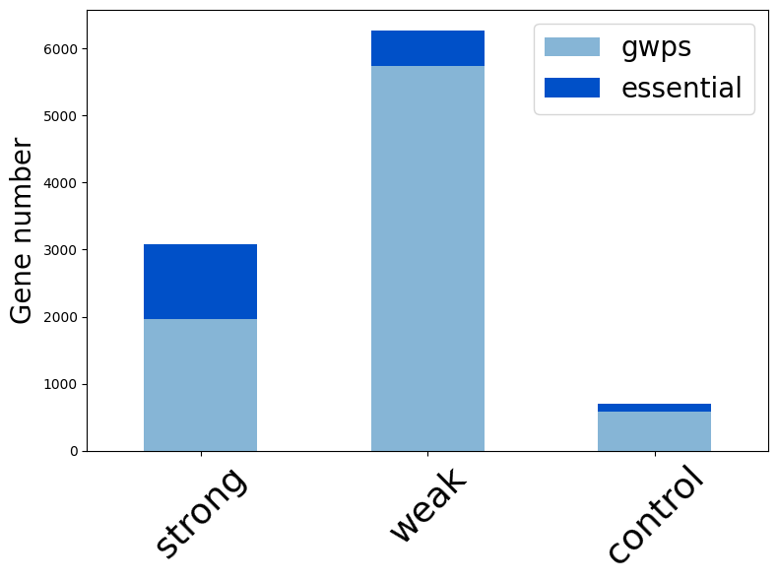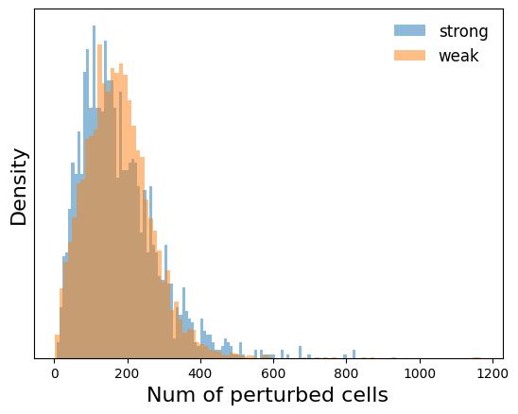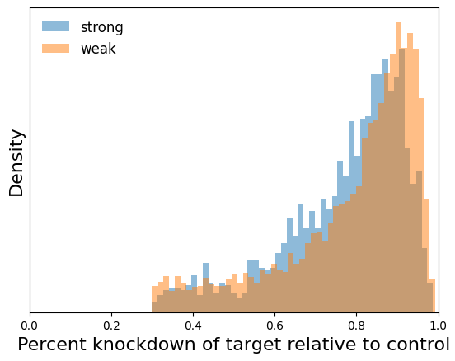

Fig. 1Quality control and screening of strongly perturbative genes.(Left,paperFig S2-G) K562 essentialand K562gwpsThe number of genes with strong and weak perturbations in the dataset;(Mid,paperFig S2-I)Distribution of cell numbers in strong and weak perturbation sequencing;(Right,paperFig S2-J)Strong and weak perturbation knockdown ratio distribution

We identified 1966 strong perturbations in the K562-gwps dataset, consistent with the 1973 perturbations reported in the literature. To determine whether the strength of the perturbation effect stemmed from the perturbation itself rather than sequencing bias, the literature analyzed the number of cells detected with strong and weak perturbations and the expression level of the target gene relative to the control (Fig. 1). They found that these two metrics were not significantly different for strong and weak perturbations, indicating that sequencing bias is not the primary factor causing the difference between strong and weak perturbations. Our reproduced results are consistent with the original study.

Next, we used KEGG enrichment analysis to explore the differences in genes causing the strong and weak perturbations (Fig..2) Consistent with the literature results, our results also show that genes causing strong perturbations are mainly enriched in RNA-related processes, such as ribosomes and RNA transport. Weak perturbations, however, do not show significant functional enrichment.

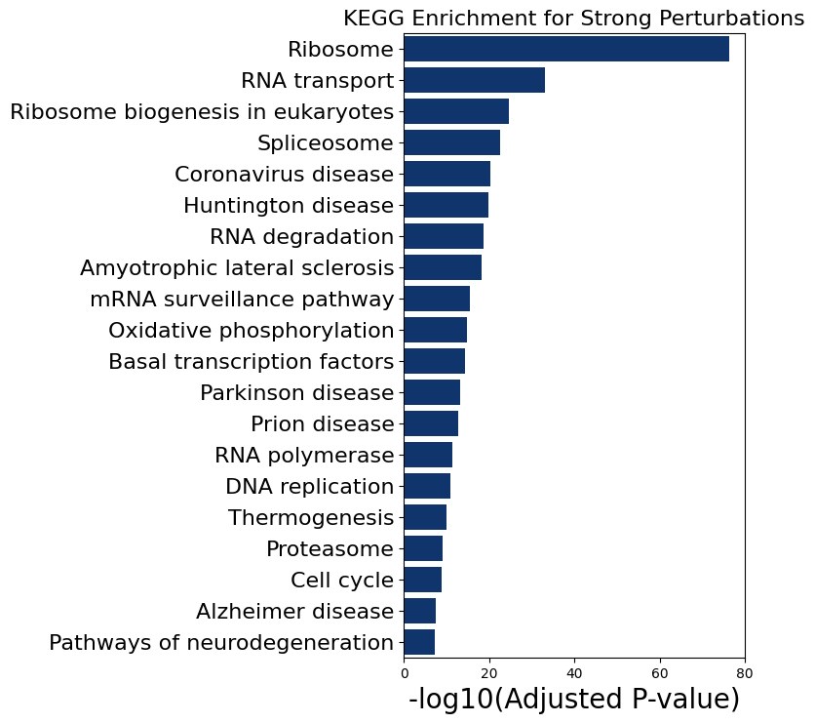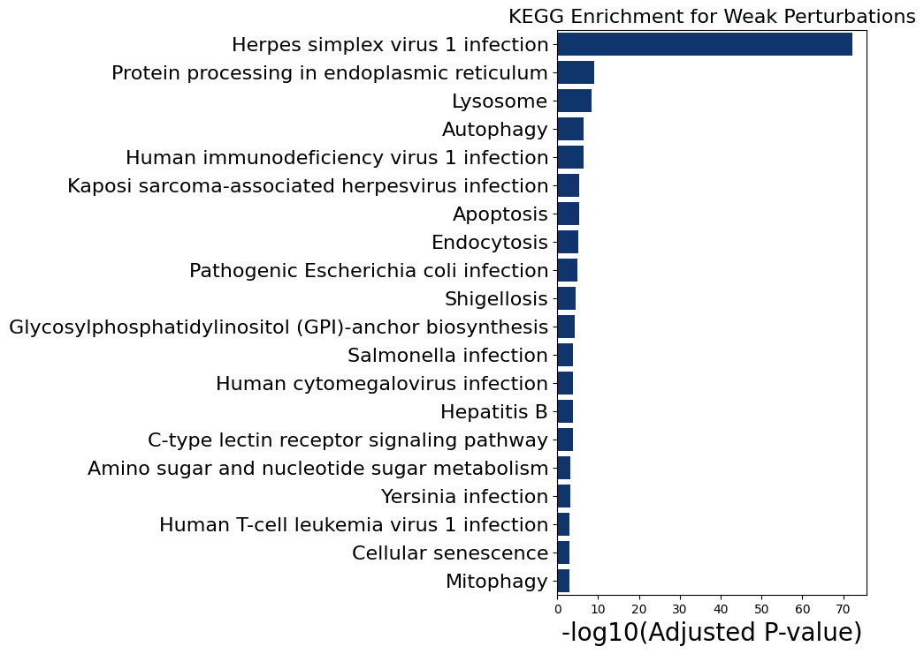

Fig. 2 (paperFig S2-F) K562 gwpsStrong and weak perturbations in the dataKEGG pathway enrichment.

2. Define gene function using Perturb-seq

Since most genes have low expression levels, we selected the 2319 most highly variable genes based on the calculated CV values ​​from the downloaded data to analyze gene function (Fig. 3 left). Considering that related perturbations may have varying degrees of effect, the authors used the correlation between each pair of perturbations as a similarity metric for scale-invariants. We calculated the correlation matrix between 1966 strongly perturbations using the same method as the original paper (Fig. 3 mid). To confirm that the obtained correlation matrix represents the common function of genes, the authors used the CORUM 3.0 dataset (https://mips.helmholtz-muenchen.de/corum/download) for validation. CORUM is a protein complex dataset that records manually annotated mammalian protein complex data; all data are derived from individual experiments, ensuring high reliability. The 1966 strongly perturbed genes contained 14690 interaction pairs of 327 protein complexes in CORUM. The correlation between these interacting proteins (median 0.30) was significantly greater than that between all gene pairs (median 0.05) (Fig. 3 right). These results are consistent with the original paper.

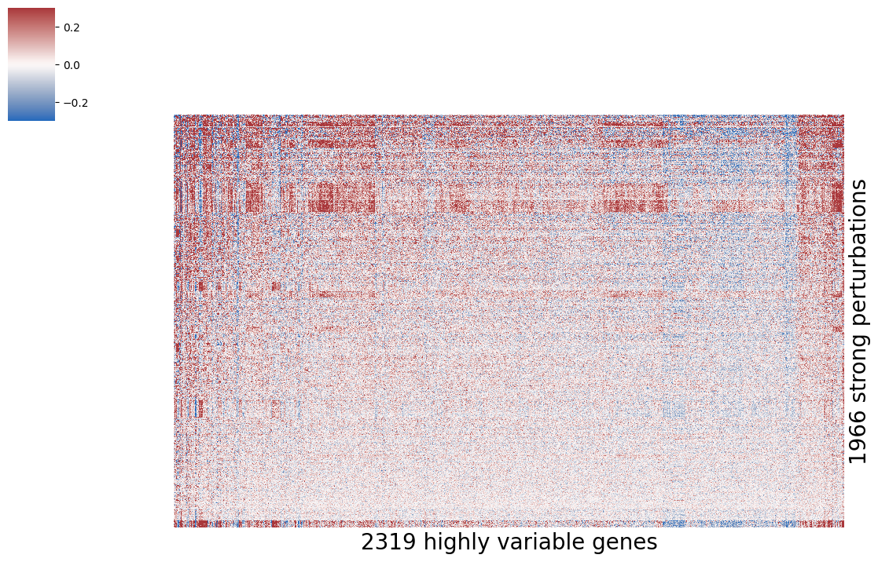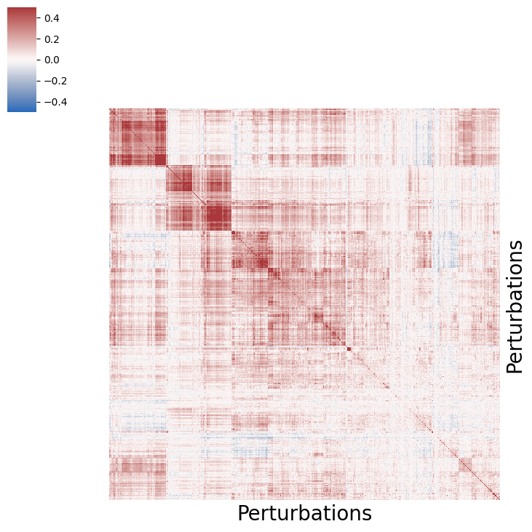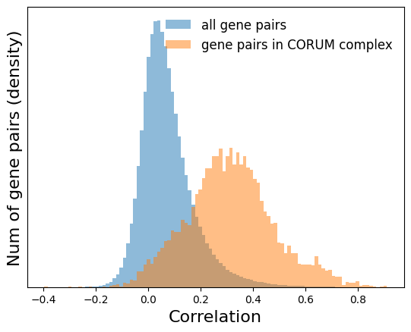

Fig. 3The correlation matrix between disturbances.(Left,paperFig 2-A) Strong perturbations are clustered by correlations in highly variable gene expression.:(Mid,paperFig 2-A)Correlation matrix between strong perturbations;(Right,paperFig 2-B)Compare all gene pairs and in327indivualCORUM3.0 protein complexesCorrelation distribution of gene pairs in

Next, we used the HDBSCAN method mentioned in the original paper for functional clustering. The paper used a min_cluster_size of 4, but this didn't work well in our experiment, finding only a few clusters. After adjusting it to 3, we found 61 clusters, close to the 64 clusters in the original paper. We used the minimum distortion embedding (MDE) method to visualize these 1966 perturbations (Fig. 4), with each cluster marked with a different color. The authors of the paper manually annotated these 64 clusters; we were only interested in the functionality of some of these clusters, so not all of them were annotated.conductNotes.

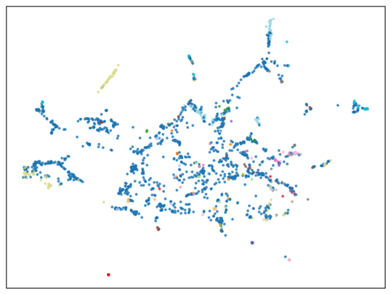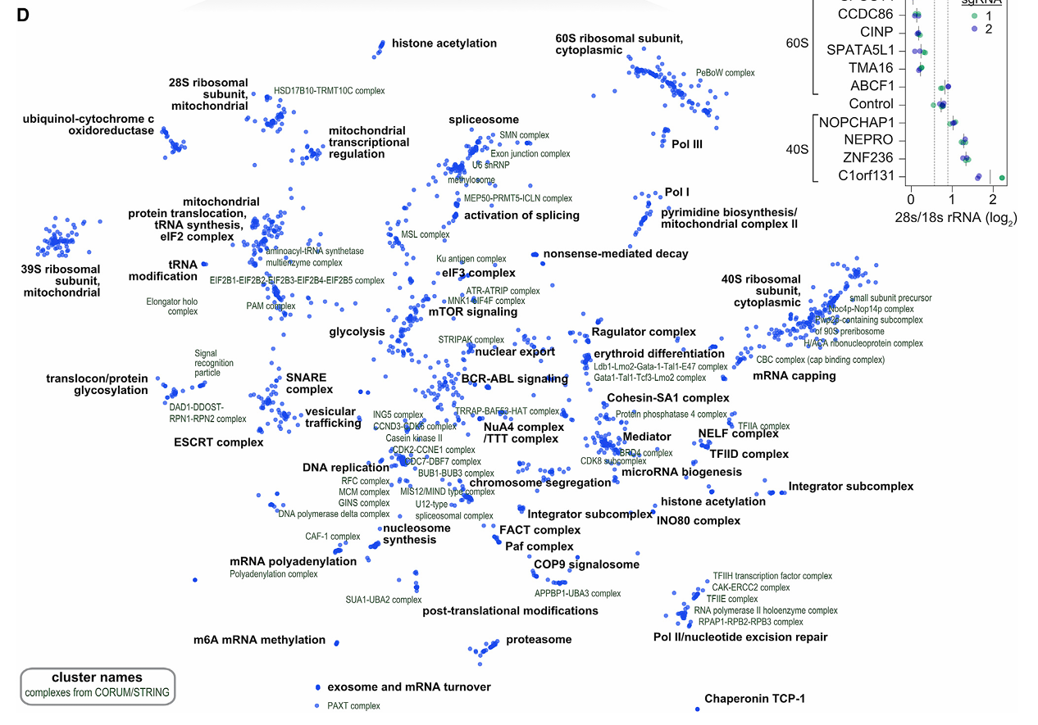

Fig. 4 (paperFig 2-Cthe right figure)useMinimum distortion embeddingVisualize the disturbance

3. Compare the similarity of perturbations between different datasets.

Next, we compared the correlation of perturbations across all three datasets. The perturbations showed a relatively high correlation between the two datasets in K562 (Fig. 5 left, r=0.68), but a lower correlation between different cell lines (Fig. 5 mid, r=0.29). We then analyzed the functions of the perturbations with high correlation between different cell lines, finding that most were enriched in RNA-related processes such as spliceosomes and RNA transport. However, the enrichment analysis of less correlated perturbations did not reveal a clear function (Fig. 6).

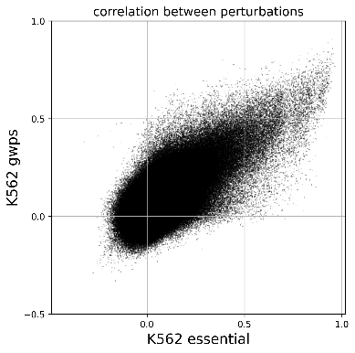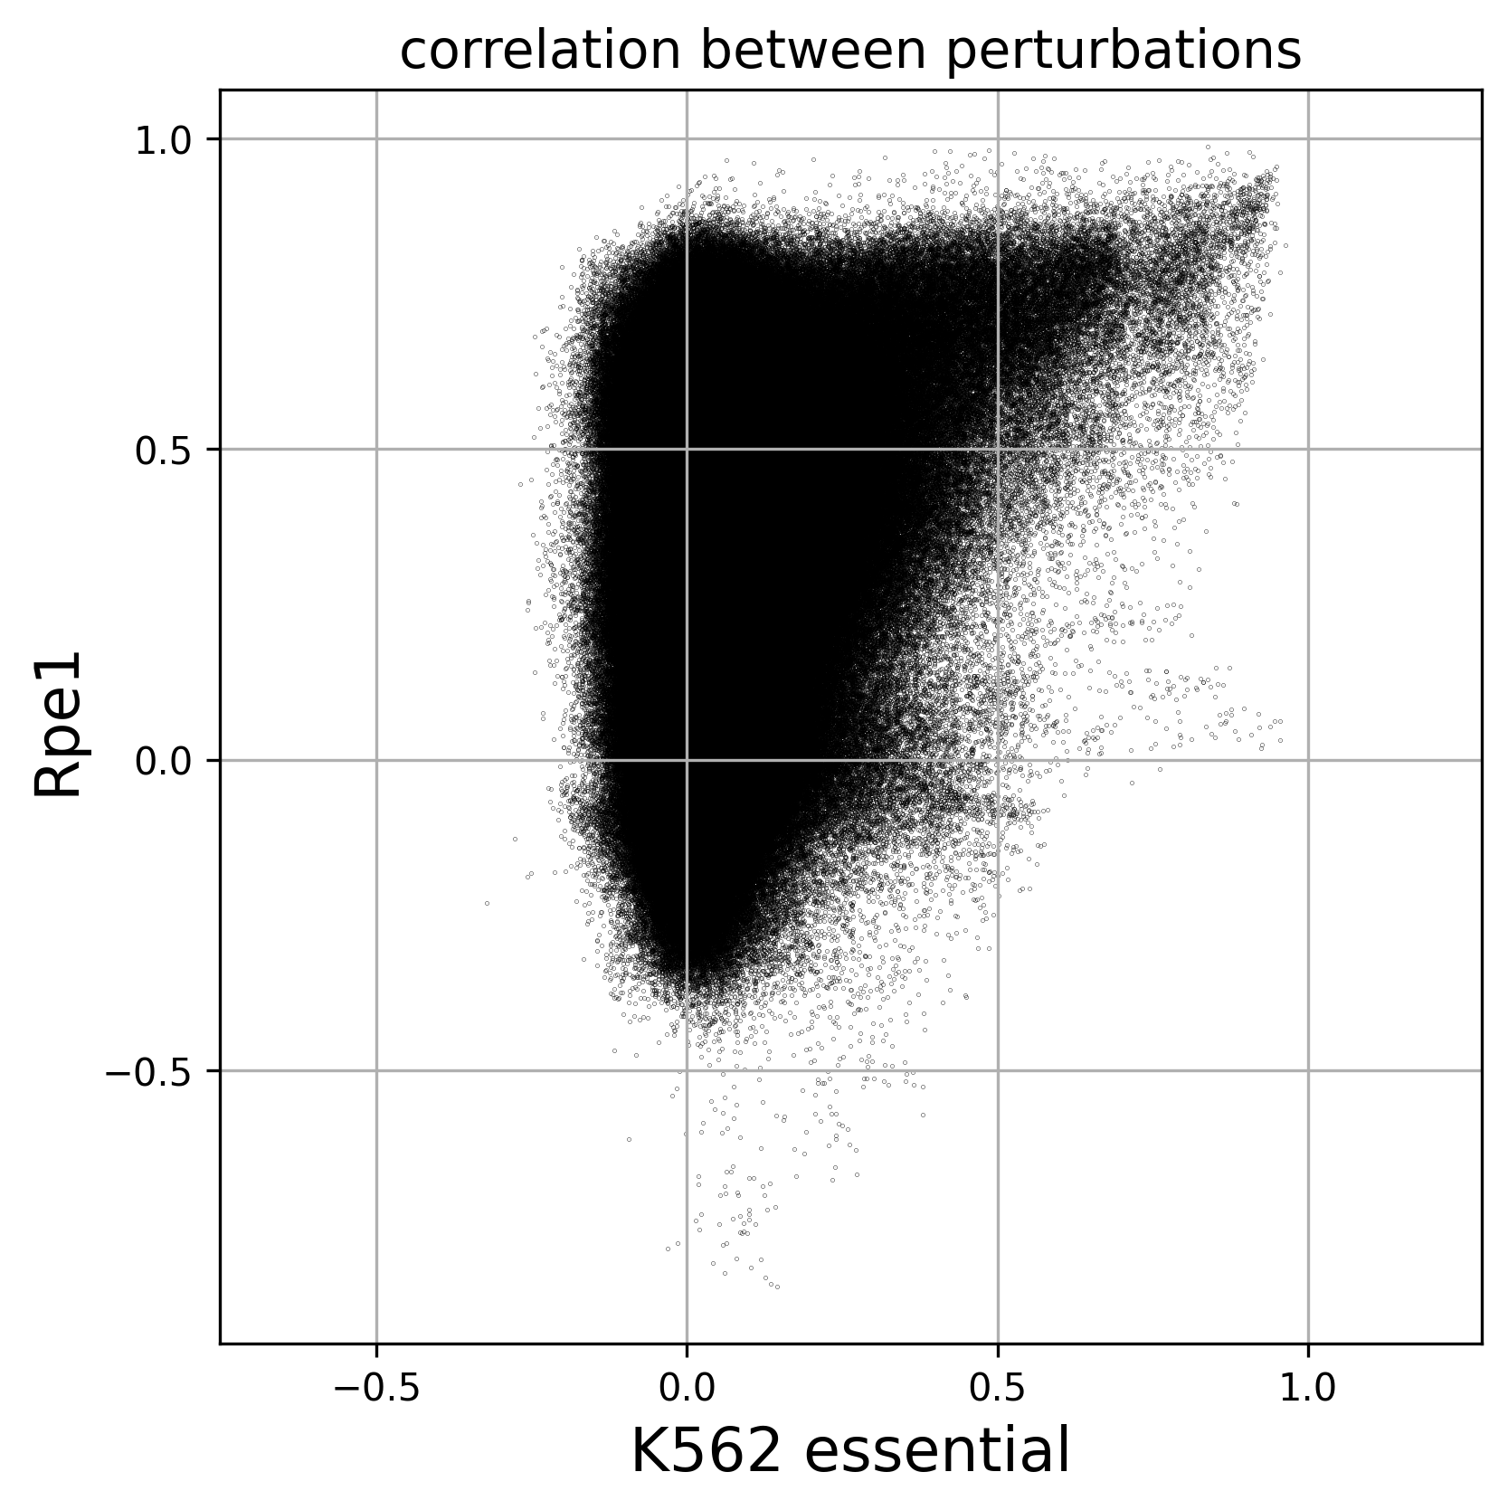 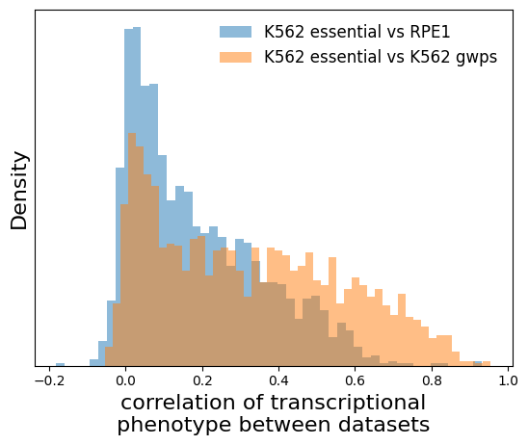

Fig. 5Compare the similarity between different datasets.(Left,paperFig S4-A)CompareK562 gwpsandK562 essentialSimilarity between them;(Mid,paperFig S4-C)Compare rpe1 essential andK562 essentialSimilarity between them;(Right,paperFig S4-B)The correlation distribution of perturbations between datasets.

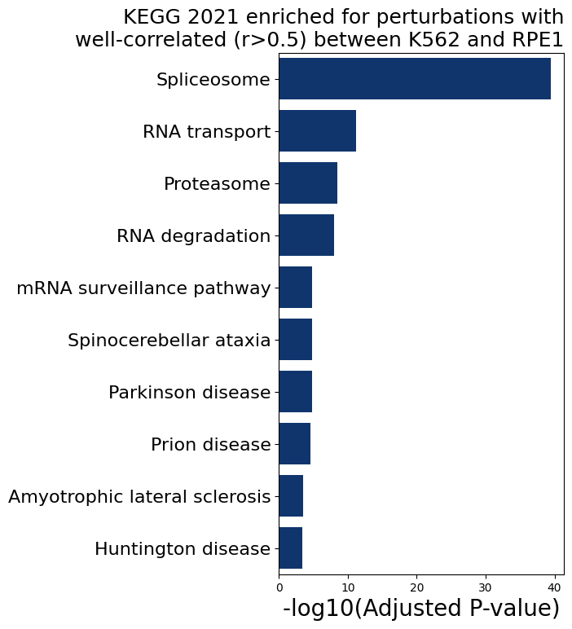 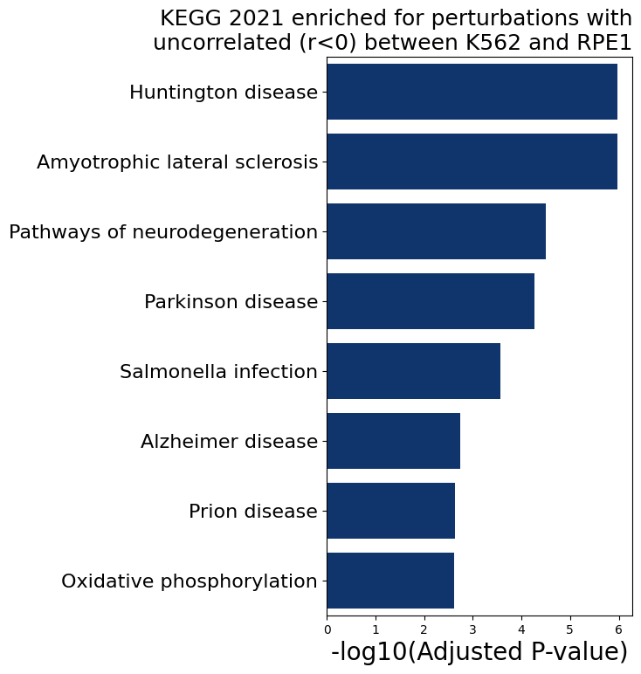

Fig. 6 (paperFig S4-DE)Between K562 essential and RPE1 well-correlated (r > 0.5)andun-corelated (r<0)The disturbanceKEGG pathway enrichment.

4. Perturb-seq can be used to annotate genes with unknown functions.

The article points out that many genes with unknown functions in the dataset show a high correlation with the perturbation effects of genes with known functions. The article presents perturbations of several unknown genes highly correlated with ribosomal subunit genes and calculates the 28S rRNA/18S rRNA ratio to illustrate that these unknown genes may indeed be unknown components of the ribosome or participate in the ribosome formation process. We use these genes mentioned in the article to create a correlation clustering heatmap (Fig. 7), and the results are consistent with the article, showing that large and small subunits are separated, and the correlation coefficients between genes are very high.

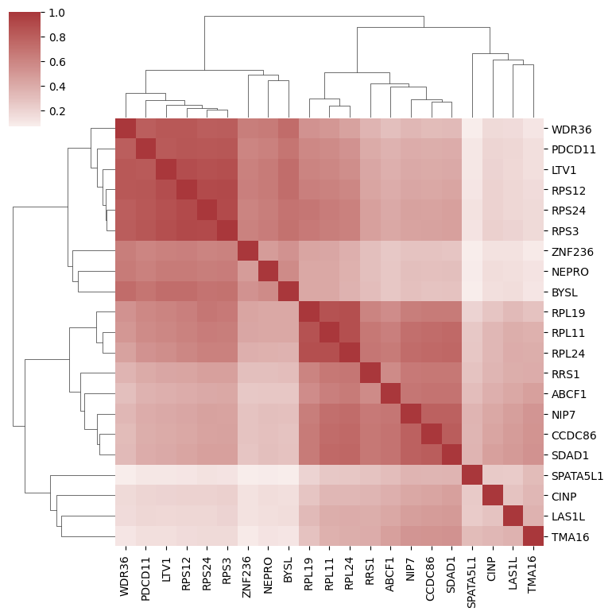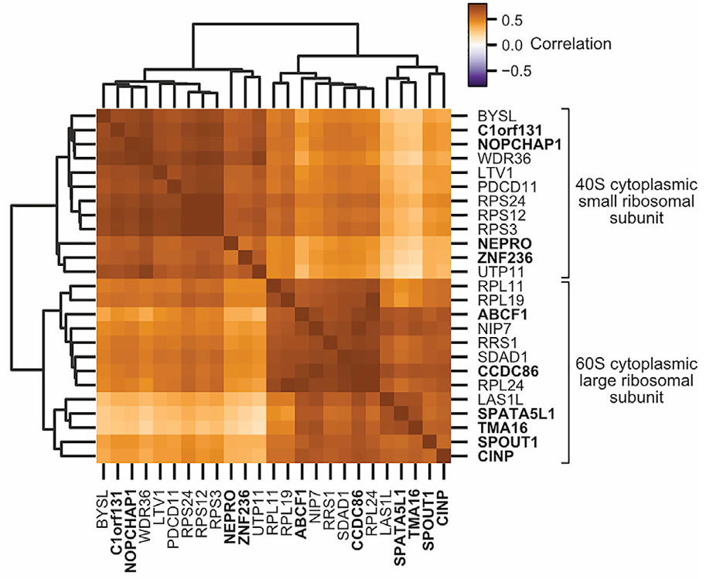

Fig. 7 (paperFig S4-Fthe right figure)Ribosomal subunit componentsbiogenesis factorsHeatmap of Poisson correlation coefficients with genes of unknown function.

5. Discovery of new components of ribosomal subunits

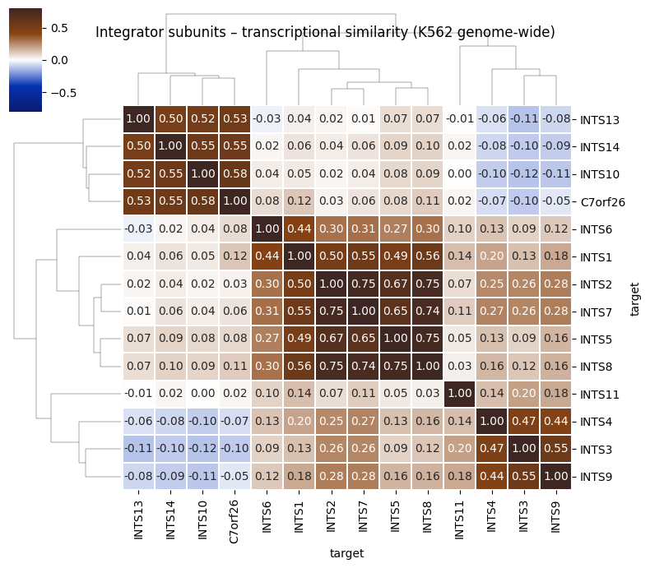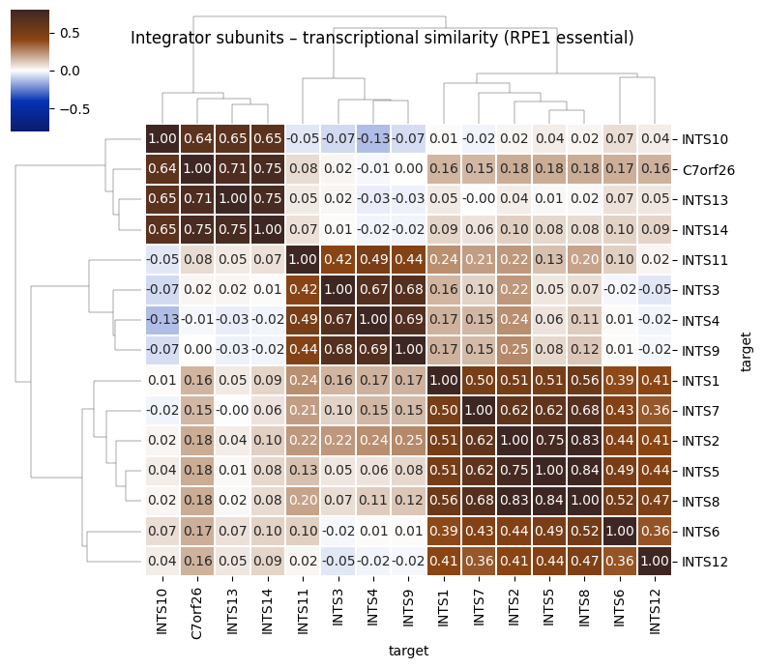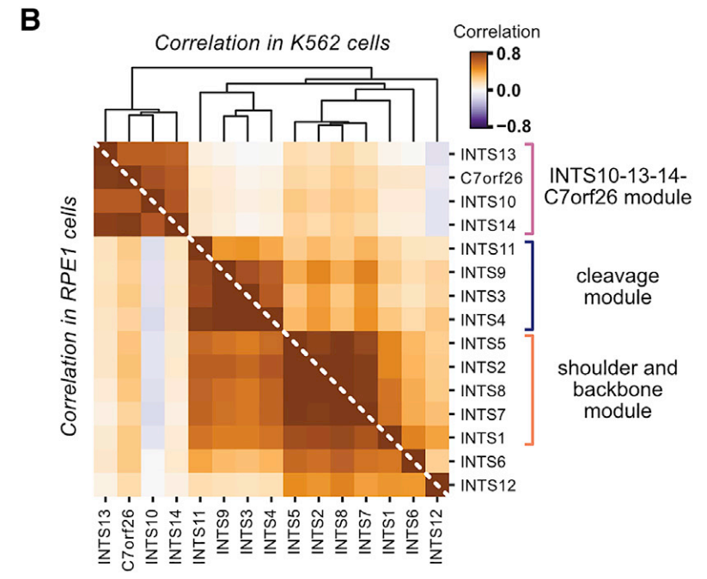

Fig. 8Relationship between integrin complex members and C7orf26 in K562 and RPE1 cells. (Heat)pictureshowRibosomesPearson correlation between gene expression profiles.The left image shows a replica of the results for the K562 cell line, the middle image shows a replica of the results for the PRE1 cell line, and the right image shows the results from the original paper.

Following the clustering strategy in the original paper, we plotted the correlation heat of gene expression profiles as shown in Fig. 8.pictureIn unannotated gene function prediction, C7orf26 formed a stable cluster with the Integrator complex subunits INTS10, INTS13, and INTS14, suggesting that these four may constitute a functional submodule. Given that these complex subunits are known not to participate in the splicing process during snRNA biogenesis, it is inferred that the function of C7orf26 is consistent with this. The original study confirmed through experiments such as immunoprecipitation that C7orf26 is a novel subunit of the Integrator complex (named INTS15), highlighting the innovative value of Perturb-seq technology in the discovery of unannotated gene function.

6. Genotype-Phenotype Map Construction

Following the parameter settings in the original paper and considering computational limitations, a strongly perturbed group was selected (the original paper used a fully perturbed group, thus reducing the number of clusters). The HDBSCAN unsupervised clustering strategy recommended in the original paper was applied, and perturbation clustering was performed based on expression profile correlations, resulting in 40 discrete perturbation clusters. Addressing the characteristics of insignificant gene expression differences and low correlations, all gene data were used, combined with 20-dimensional MDE embeddings and HDBSCAN unsupervised clustering, to identify 32 gene co-expression programs (Fig.).9).The pyMDE 2D visualization results show that the cluster separation of the gene expression program is significantly improved after MDE embedding, but the clusters are still not tight enough and the noise ratio is relatively high, which is consistent with the original description.

After filtering out noise perturbations and genes, the average z-score of gene expression programs in each perturbation cluster was calculated, and a numerical matrix of "perturbation cluster × gene expression program" was constructed and a heatmap was plotted. The perturbation cluster division reflects the functional correlation of genes. For example, ribosomal subunit genes and mitochondrial metabolism genes were clustered into independent clusters, which is highly consistent with the functional annotations in the original text.

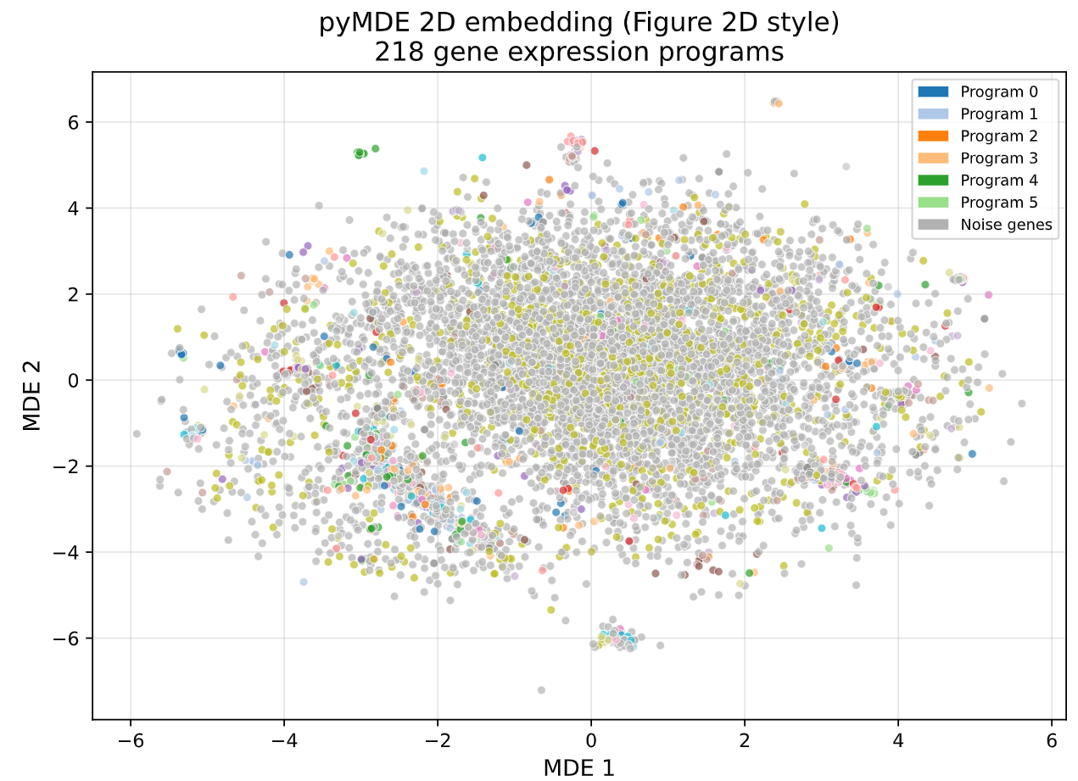

Fig. 9 Visualization of gene expression program clustering (2D MDE embedding)

The expression programs of the 38 genes are discretely distributed, and the noise genes are marked in gray.

Functional annotation revealed that function-related genes still clustered together, indicating that high-dimensional embedding combined with unsupervised clustering can effectively identify biologically significant sets of co-regulated genes. The final genotype-phenotype heatmap was constructed.pictureIt presents a clear functional relationship pattern, which is highly consistent with the original Fig. 4B.(Fig. 10).

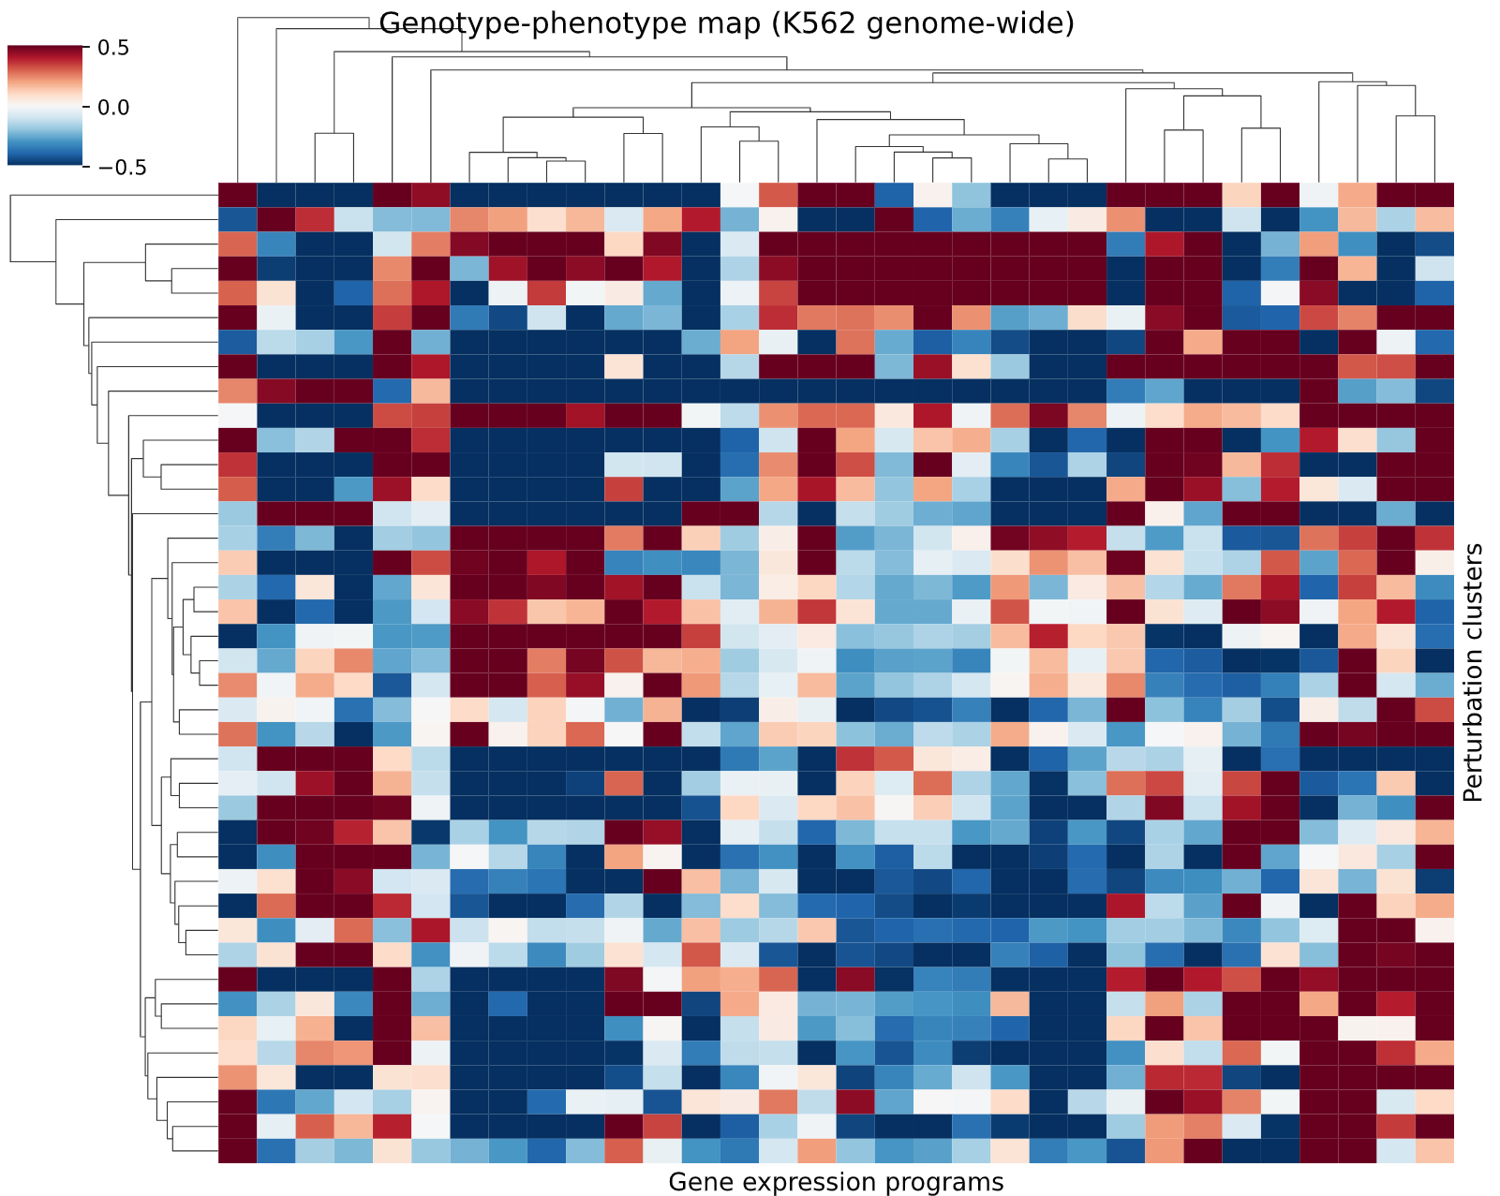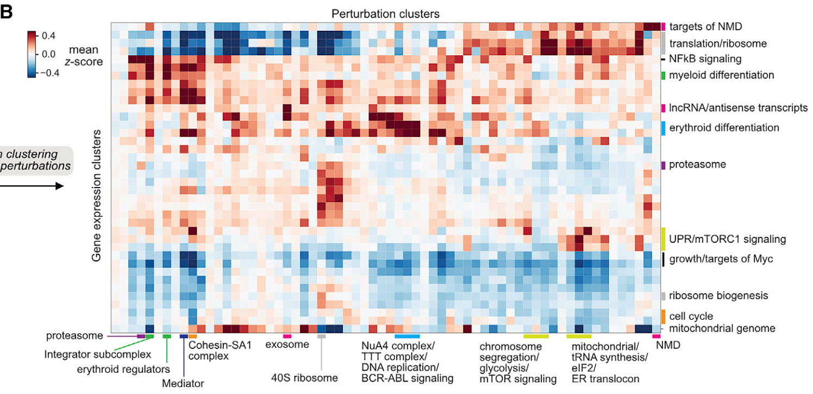

Fig.10 Genotype-PhenomenonpictureSpectral Thermometrypicture.OKThe column is marked as shown in the figure.Disturbance clusterandGene expression programs are represented by colors indicating the average z-score expression level of the corresponding gene expression program in each perturbation cluster (red = upregulated, blue = downregulated). Rows and columns are clustered hierarchically, with functionally related modules closely adjacent, reflecting the systematic association between genotype and phenotype.The left image shows the replicated result, and the right image shows the original result.

7. Transcription program and differentiation phenotype analysis

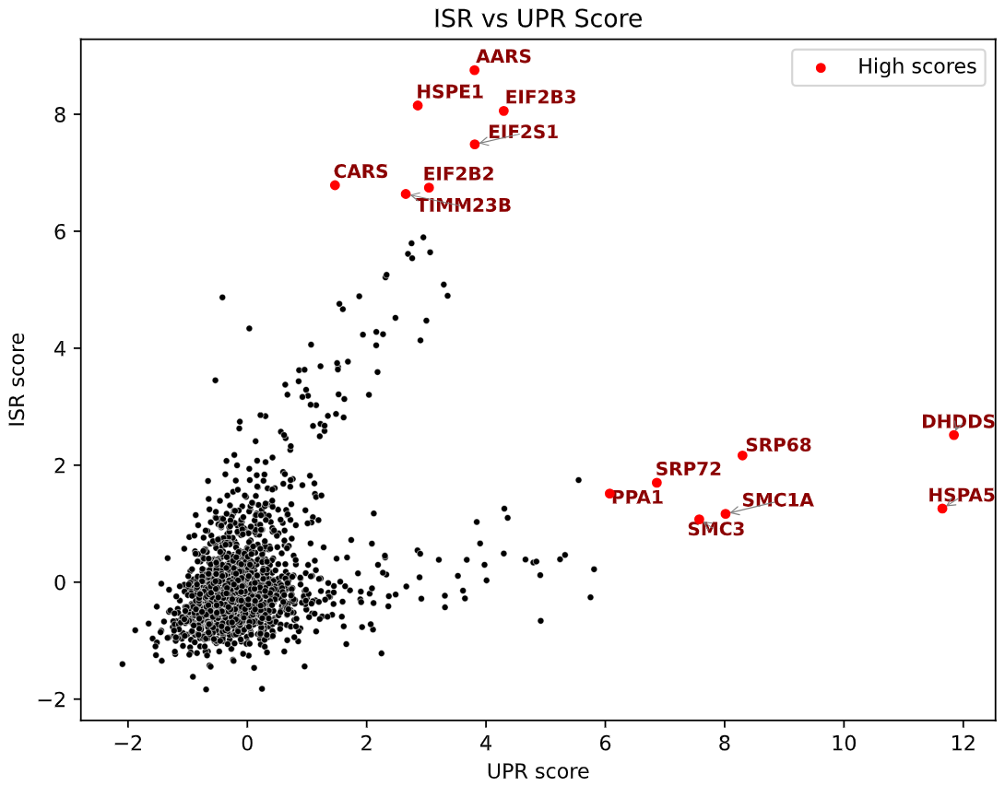 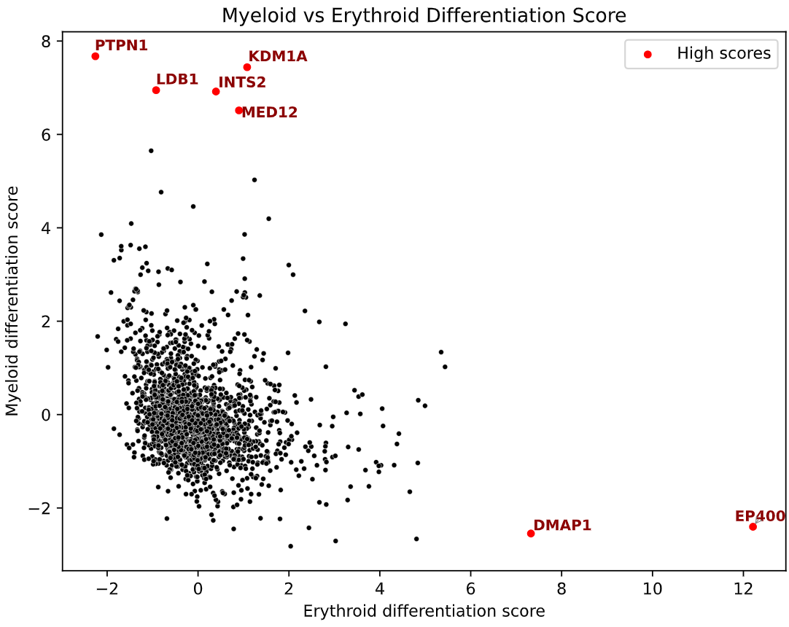

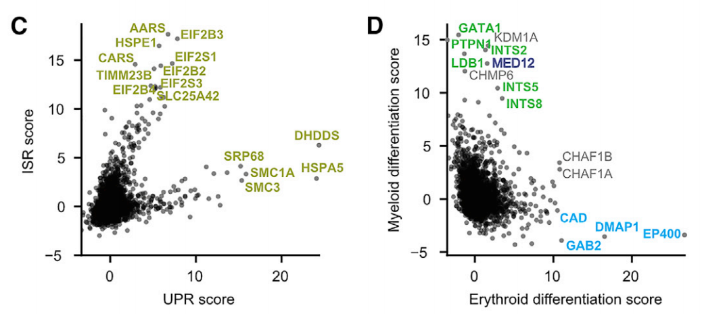

Fig. 11 Left: HeredityComparison of perturbation ISR and UPR scores.The right isA comparison of the effects of genetic perturbation on the differentiation scores of erythroid and myeloid lines.The top image is a replica, and the bottom image is the original image. Genes are labeled as discrete at the origin.

Based on the functional gene set validated in the original paper, four categories of core transcriptional program characteristic genes were defined (Integrated Stress Response (ISR), Unfolded Protein Response (UPR), Erythrocyte Differentiation, and Myeloid Differentiation). After screening characteristic genes, the expression matrix was z-normalized to eliminate differences in gene expression levels. The average z-score of each perturbation in the four gene sets was calculated as the transcriptional program activation intensity. Finally, global z-normalization was performed on the program scores to ensure scale comparability. Scatter plots were used to...pictureThe association between two key phenotypic types is shown, and genes discrete at the origin are labeled.

The results showed that ISR and UPR scores were weakly correlated and separated, validating their functional independence. The high-scoring UPR cluster (right side of the x-axis) was enriched with ER-related gene perturbations, and their knockdown directly activated the UPR pathway. The high-scoring ISR cluster (above the y-axis) was concentrated with perturbations of mitochondrial function and amino acid metabolism genes, consistent with the specific response of ISR to energy metabolism imbalance and protein homeostasis disorder. Most perturbations were located near the origin, and only perturbations of specific functional genes induced targeted stress responses.

Erythrocyte and myeloid differentiation scores showed a bidirectional separation, clearly reflecting the regulation of K562 cell multi-lineage differentiation potential: the high-scoring erythrocyte differentiation cluster (right side of the x-axis) contained key perturbations consistent with the original study; the high-scoring myeloid differentiation cluster (above the y-axis) was enriched with core positive regulatory genes of erythrocyte differentiation, and knockdown of these genes led to cell shift towards myeloid differentiation; most perturbations were located near the origin, indicating that only perturbations of key lineage regulatory genes significantly altered cell differentiation fate.Fig. 11).

8. Stress-specific regulation of the mitochondrial genome

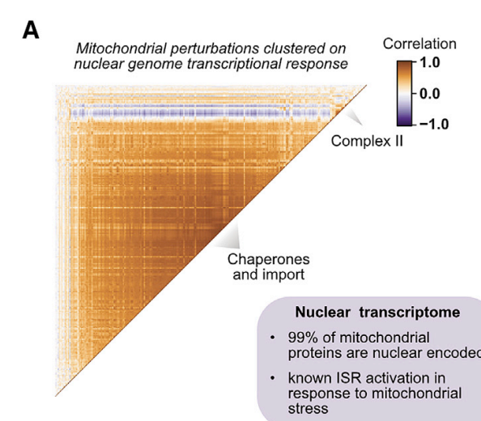 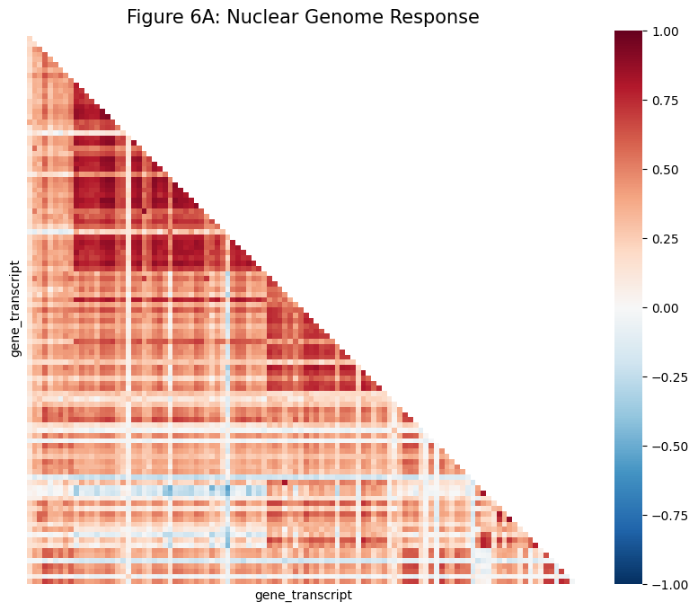

Fig. 12Mitochondrial perturbation clustering analysis based on nuclear transcription response

Pearson-related heat based on nuclear gene expression profilingpicturePearson correlation coefficients were calculated among the expression profiles (Z-score normalized) of nuclear-coding genes in K562 cells with strong phenotype mitochondrial perturbation (n=140), and the results were sorted by hierarchical clustering.Original image on the left, replica on the right.

Fig. 12This study presents a correlation matrix of changes in the expression profiles of nuclear-encoded genes after CRISPRi perturbation targeting different mitochondrial functional modules (such as the respiratory chain complex, mitochondrial ribosomes, and protein transport channels) in K562 cells. Despite the diverse functions of the targeted mitochondrial genes, the transcriptomic changes they induced in the nucleus showed a high degree of consistency. (Correlation heat)pictureThe large area of ​​highly correlated modules presented in the data suggests that different types of mitochondrial stress activate the same set of nuclear gene expression programs.

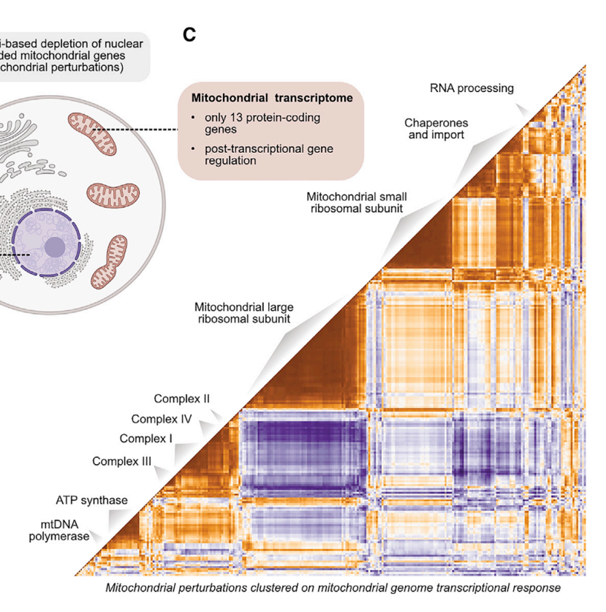 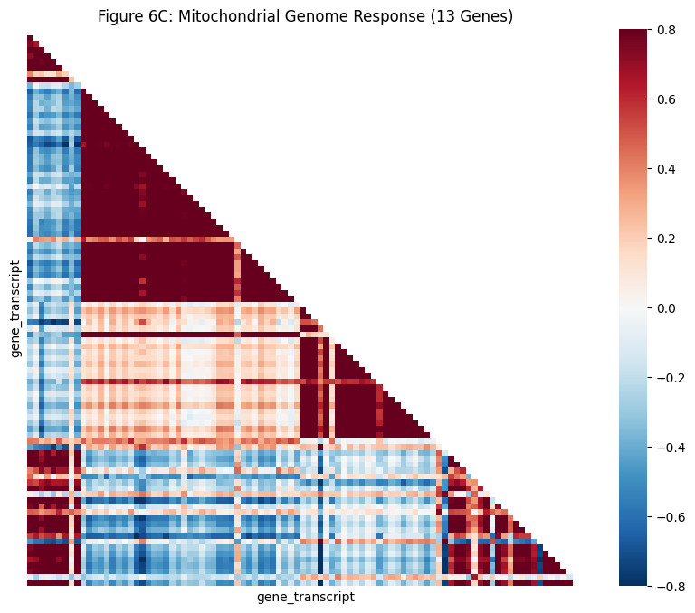

Fig. 13Mitochondrial perturbation clustering analysis based on mitochondrial transcriptional response

Pearson-related heat based on mitochondrial gene expression profilingImage. Left: Original image; Right: Replica.

Fig. 13This demonstrates the changes in expression profiles induced by the same mitochondrial perturbations at the mitochondrial coding gene level. Unlike the nuclear genome, the transcriptional responses in the mitochondrial genome exhibit clear, function-specific clusters in the thermal Fig..

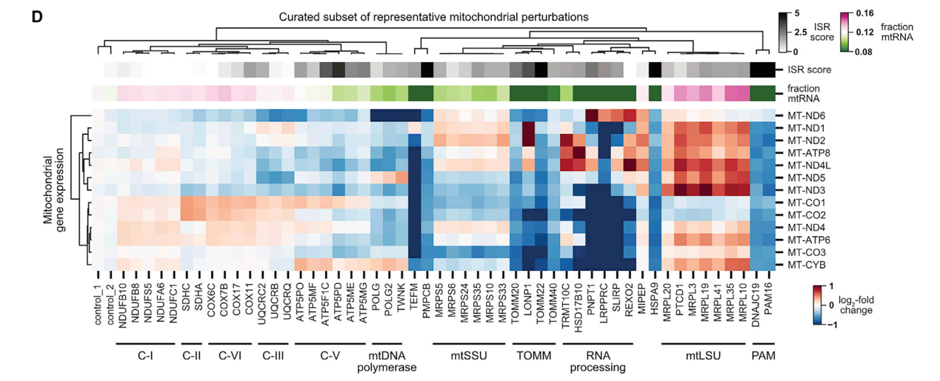

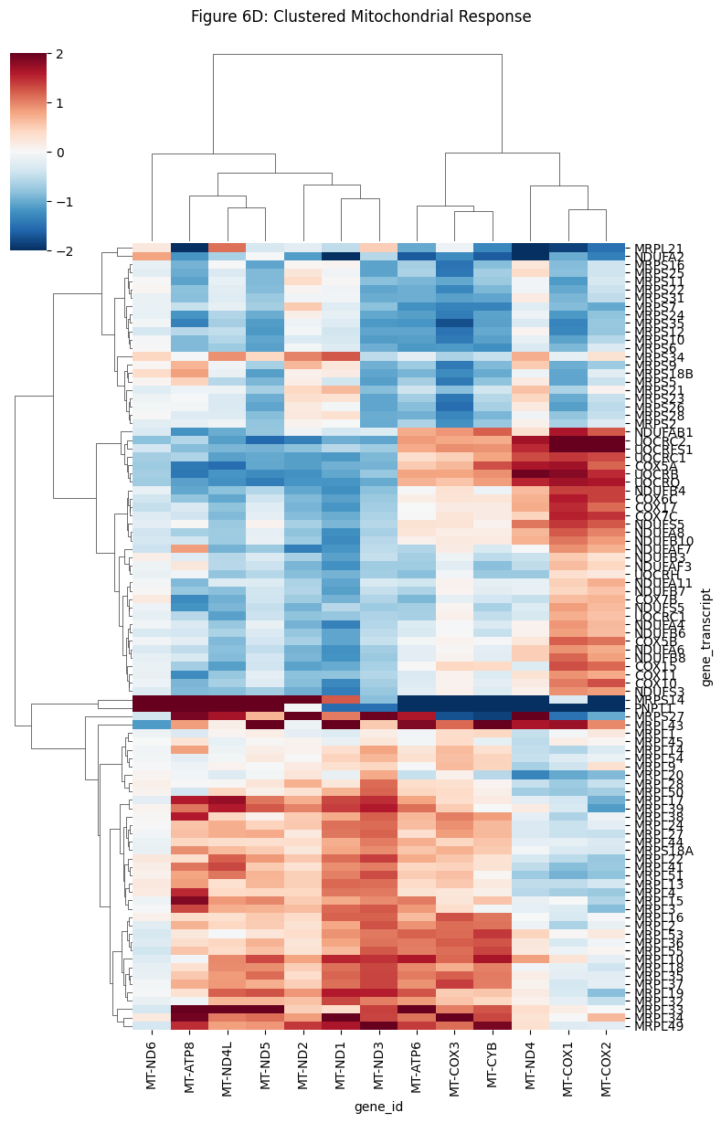

Fig. 14Activity analysis of mitochondrial genome program under different perturbations

Bidirectional clustering of mitochondrial gene expression levelspicture.The normalized expression levels of 13 mitochondrial genes (rows) are shown in the perturbation samples (columns) that caused the most significant changes in mitochondrial transcription. Red indicates upregulation, and blue indicates downregulation.Original image above, replica image below.

Fig. 14Mitochondrial gene expression profiles were used as high-dimensional phenotypes to perform co-regulatory analysis on mitochondrial genes with unknown functions. Fig. highlights the high degree of overlap in clustering between the gene TMEM242 and ATP synthase subunits (such as ATP5F1A and ATP5PO). Among thousands of perturbations, the mitochondrial gene expression changes induced by TMEM242 knockdown were almost identical to those induced by direct knockdown of the ATP synthase core subunit.

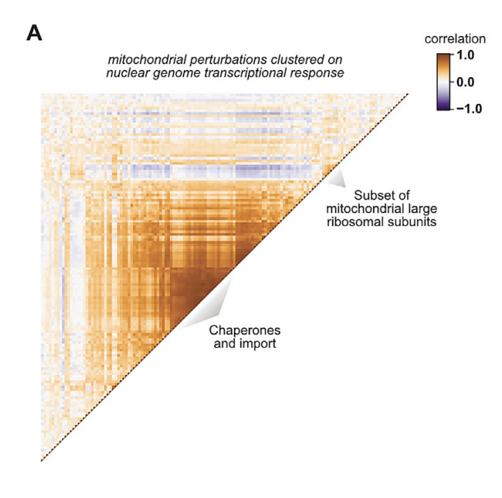 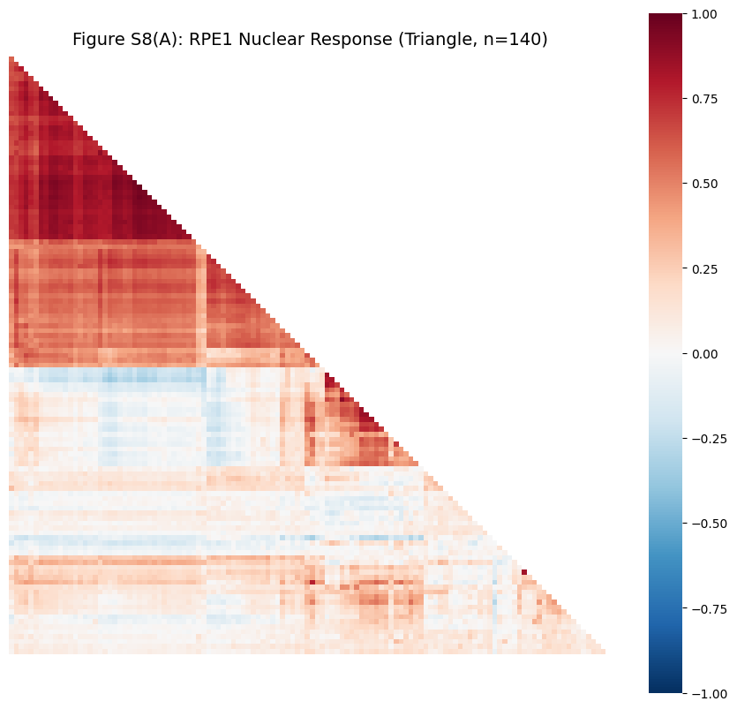

Fig. 15Mitochondrial perturbation clustering analysis based on nuclear transcriptional response in RPE1 cells

Pearson-related heat in RPE1 cells based on nuclear gene expression profilespicture.Original image on the left, replica on the right.

Fig. 15This study demonstrates the correlational clustering of nuclear gene expression profiles induced by strong phenotype mitochondrial perturbations in RPE1 cells, screened through annotation. Highly consistent with results from K562 cells (6A), RPE1 cells exhibit a highly modular transcriptional response to different types of mitochondrial dysfunction.pictureLarge-scale, highly correlated blocks have reappeared.

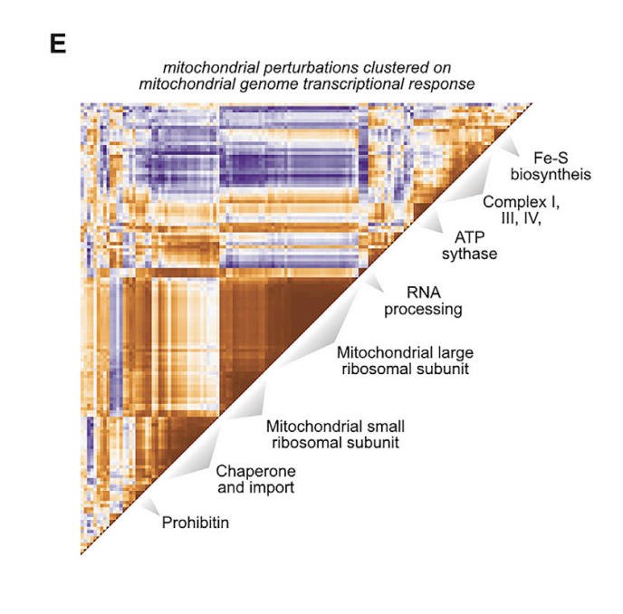 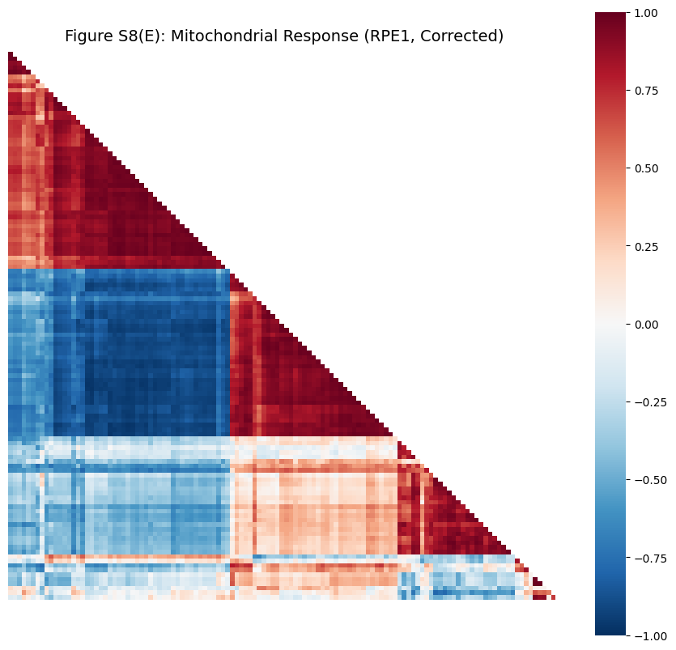

Fig. 16Mitochondrial perturbation clustering analysis based on mitochondrial transcriptional response in RPE1 cells

Pearson-related heat based on mitochondrial gene expression profiles in RPE1 cellspicture.Original image on the left, replica on the right.

Fig. 16This study focuses on the effects of 140 mitochondrial perturbations in RPE1 cells on 13 mitochondrial-coding genes. Unlike the nuclear genome, the mitochondrial gene expression profiles in RPE1 cells again show function-specific clustering. For example, knockdown of different respiratory chain complexes elicits specific mtDNA transcriptional fingerprints.

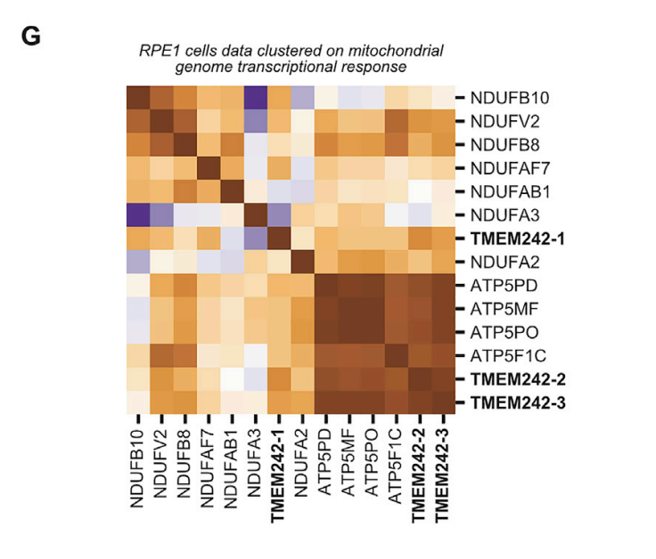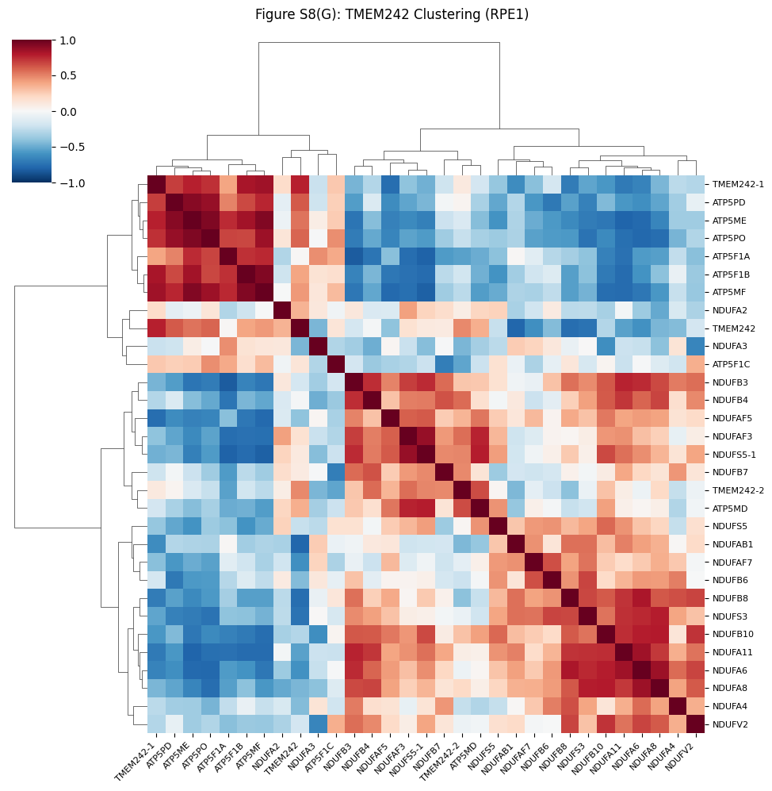

Fig. 17TMEM242 genetic perturbation clustering analysis based on mitochondrial transcriptome in RPE1 cells

TMEM242 correlational clustering heat of RPE1 cells based on mitochondrial transcriptional fingerprintpicture.Original image on the left, replica image on the right.

Fig. 17Cluster analysis was performed specifically targeting the genetic perturbations of TMEM242 and the perturbations of ATP synthase and Complex I members. This analysis was based on mitochondrial transcriptome data from RPE1 cells. In the RPE1 cell context, the perturbation samples of TMEM242 still clustered tightly with ATP synthase subunits (showing co-upregulation of mtDNA genes), while clearly distinguishing them from Complex I.

IV. Innovative Discoveries

In the analysis of the genotype-phenotype of Fig. S5A in the original textpictureDuring the analysis, we noticed a close clustering of histone gene cluster 3 and the dysregulated long non-coding RNA (lncRNA)/antisense transcript cluster 5, a phenomenon that piqued our research interest. Using methods consistent with our previous transcriptional procedure and differentiation phenotype analysis, we integrated the expression data of these two gene clusters and plotted a scatter plot of the effects of genetic perturbation on histone genes and dysregulated lncRNA/antisense transcripts.picture.

The results showed that genetic perturbations of multiple genes had similar regulatory effects on the expression of these two types of genes. Further analysis revealed that among these genes, DIS3, EXOSC2, EXOSC3, EXOSC4, EXOSC5, EXOSC6, and EXOSC8 were all core subunits of the exosome complex. The exosome complex is a highly conserved multi-subunit RNA degradation machine in eukaryotic cells, and its core function is to mediate the 3'→5' direction of RNA degradation [2]. Knockdown of these subunits significantly upregulated the expression of histone genes and dysregulated lncRNA/antisense transcripts, which is consistent with the conclusion of previous studies that "histone gene transcripts and lncRNA/antisense transcripts are both regulated by the exosome complex for degradation" [3][4]. The essence is that the half-life of the two types of RNA substrates is synchronously prolonged after the exosome degradation function fails.

Notably, we compared the effects of exonucleosome complex gene knockdown on genome-wide genes and found that its upregulation effect on histone genes and dysregulated lncRNAs/antisense transcripts was most significant. This phenomenon is presumably related to the inherent characteristics of the two types of RNA: histone mRNAs themselves have a short half-life, while dysregulated lncRNAs/antisense transcripts, as abnormal RNA products within the cell, need to be rapidly cleared through exonucleosome-mediated quality control pathways, thus also having a short half-life and a higher dependence on degradation function. Furthermore, histone gene expression is precisely regulated by epigenetic networks, and lncRNAs/antisense transcripts are key molecules in this regulatory network. The accumulation of dysregulated lncRNAs/antisense transcripts induced by exonucleosome knockdown may form a positive feedback loop through epigenetic regulatory pathways: for example, some antisense transcripts can specifically bind to histone modification sites in the promoter region of histone genes, inhibiting the recruitment of histone deacetylases, leading to relaxation of the chromatin structure in the promoter region, and further activating histone gene transcription.

To further verify the above hypothesis, we screened genes that were significantly affected by the perturbation and performed pathway enrichment analysis. The results showed that RNA degradation pathway and mRNA stability regulation-related pathways were significantly enriched, which echoes the core hypothesis that "altered exonucleosome degradation function drives RNA substrate accumulation" and further corroborates the reliability of the conclusion.

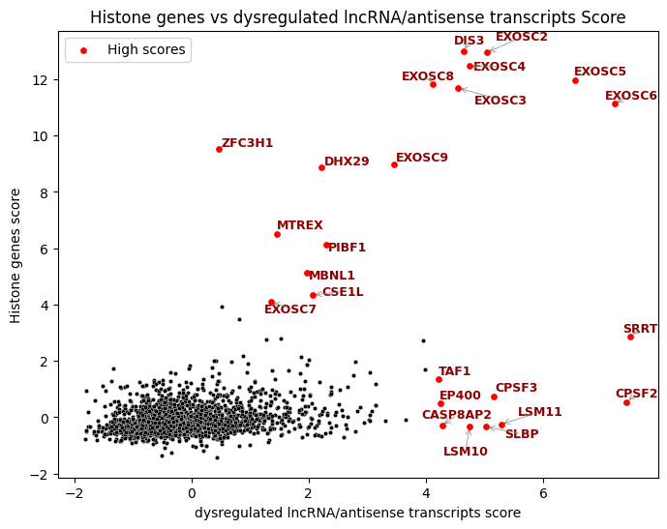 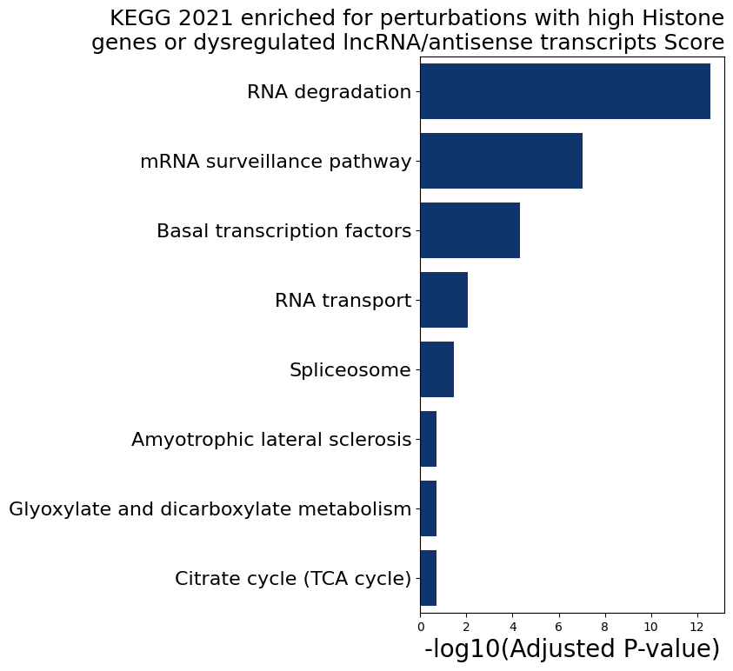

Fig.18. Left: Different inheritance patternsDisturbancehistone genesComparison with dysregulated lncRNA/antisense transcript scores.Red dots mark genes discrete at the origin. The right side shows KEGG pathway enrichment of genes with high perturbation influence; the selection criterion is that all scores are greater than 2.5.

Mutations in the EXOSC family of genes are closely associated with a variety of human diseases: for example, EXOSC2 mutations can lead to retinitis pigmentosa; EXOSC3 mutations are associated with pontocerebellar dysplasia type 1 and spinal motor neuron disease; and EXOSC8 mutations can cause cerebellar and corpus callosum dysplasia and spinal motor neuron disease [5]. This association not only helps us to reveal the potential pathogenic mechanisms of related diseases, but also provides important theoretical priors for the development of subsequent treatment strategies.

V. Summary and Outlook

This study successfully replicated the core workflow of Perturb-seq whole-genome analysis, achieving key analytical goals such as gene function annotation and complex phenotypic analysis.pictureThe table is consistent with the original text.highIn-depth analysis of transcriptome data validated the powerful capabilities of Perturb-seq technology in gene function discovery and cellular regulatory mechanism analysis, while also uncovering new gene function associations and cell type-specific regulatory patterns.

Regarding limitations, since wet-lab validation was not conducted, the functional predictions of some new genes still require confirmation through in vitro experiments; in data analysis...Clustering methodsThere is still room for optimization. Future research could further expand the analytical dimensions, combining proteomics and epigenomic data to construct multi-omics genotype-phenotype models.pictureThis expands the spectrum and broadens the coverage of cell types and disease models, providing more comprehensive theoretical support for precision medicine research.

References

[1]Replogle, JM, Saunders, RA, Pogson, AN, Hussmann, JA, Lenail, A., Guna, A., Mascibroda, L., Wagner, EJ, Adelman, K., Lithwick-Yanai, G., Iremadze, N., Oberstrass, F., Lipson, D., Bonnar, JL, Jost, M., Norman, TM, & Weissman, JS (2022). Mapping information-rich genotype-phenotype landscapes with genome-scale Perturb-seq. Cell, 185(14), 2559–2575.e28. https://doi.org/10.1016/j.cell.2022.05.013

[2]Zhang, W., Zhu, J., He, X., Liu, X., Li, J., Li, W., Yang, P., Wang, J., Hu, K., Zhang, X., Li,<https://doi.org/10.3892/ol.2019.10850>

[3]Mullen, TE, & Marzluff, WF (2008). Degradation of histone mRNA requires oligouridylation followed by decapping and simultaneous degradation of the mRNA both 5' to 3' and 3' to 5'. Genes & development, 22(1), 50–65.<https://doi.org/10.1101/gad.1622708>

[4]Canavan, R., & Bond, U. (2007). Deletion of the nuclear exosome component RRP6 leads to continued accumulation of the histone mRNA HTB1 in S-phase of the cell cycle in Saccharomyces cerevisiae. Nucleic acids research, 35(18), 6268–6279.<https://doi.org/10.1093/nar/gkm691>

[5]Nair, L., Chung, H., & Basu, U. (2020). Regulation of long non-coding RNAs and genome dynamics by the RNA surveillance machinery. Nature reviews. Molecular cell biology, 21(3), 123–136.<https://doi.org/10.1038/s41580-019-0209-0>